Project Report on

**E-Commerce**

Submitted to

**JAYSHREE PERIWAL HIGH SCHOOL**

**3, Chitrakoot Scheme**

**JAIPUR**

In partial fulfillment of

the requirements for

**All India Senior School**

**Certificate Examination 2021**

Of

**Central Board of Secondary Education**

Submitted By: **Ishita Agrawal**

**Acknowledgement**

We would like to thanks everyone who helped us to

accomplish this project.

Our sincere thanks to our family members and respected

teachers, who have helped us with their valuable suggestions and support throughout the development of the project.

We are highly thankful to our project guide **Mrs. Monica** for

Providing guidance and support at every stage of the project.

We are extremely grateful to **Mrs. Jayshree Periwal**,

Director and **Mrs. Madhu Maini**, Principal of JAYSHREE

PERIWAL HIGH SCHOOL, Jaipur, for providing us a very good

computer lab, due to which this project became possible.

**Ishita Agrawal**

**CERIFICATE OF ORIGINALITY**

This is to certify that the Project Report entitled “E-Commerce” submitted to JAYSHREE PERIWAL HIGH SCHOOL in partial fulfillment of the requirement for all India Senior Certificate Examination (AISSCE) 2021 of CBSE, is an original work carried out by Ishita Agrawal under my guidance.

The matter embodied in this project is genuine work done by the students and has not been submitted of any course of

study.

.....................................................

Signature of The Guide

Date:..........................................

Name : Ms. Ranjeeta

(HOD – Computer)

**CONTENT**

|  |  |  |
| --- | --- | --- |
| S.NO. | Topic | Page No. |
| 1. | Objective & Scope of the Project | 6 |
| 2. | Details of Hardware and Software used | 7 |
| 3. | Design of Webpages | 9 |
| 4. | Source Code of the Project | 18 |

1. Objective & Scope of the Project

Objective

The main objective of the project is to provide toys to children everywhere.

E-commerce saves people’s time. It will help customer do shopping 24/7 from the comfort of their houses.

It supports nature, as people will not have to use vehicle to go to store, which will lead to minimization of smoke emitted by vehicle.

Online shopping will also help reduce spread of COVID-19.

Scope

This project is developed for selling of toys.

Further, the variety of product will be expanded, to expand the use and reach of our site to maximum number of people.

This project will help reduce infrastructure cost.

The website will be keepon updating and improving to make it easy to use.

2. Details of Hardware and Software used

Platform: Windows 7

Tools: 1. Notepad or any other text editor

2. Any Web browser

**Hardware Specifications**

Microprocessor (CPU) : Dual Core

Memory (RAM): 2 GB

Virtual Memory: 32-Bit

Hard Disk: 180 GB

VDU: SVGA

Keyboard: Standard 104 Keys

Mouse: Standard 2-Buttons Mouse

Printer: Inkjet/Laser

Software Specifications

Operating System: Windows 7

Text Editor: Notepad

Documentation: Microsoft Word 2013 and MS Paint

3. Design of Web pages

**Design**

**Of**

**Web pages**

# The **Home page** of the Project is Shown Below:

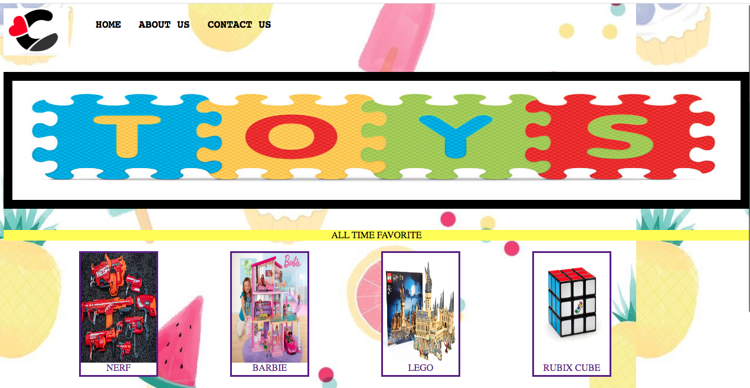

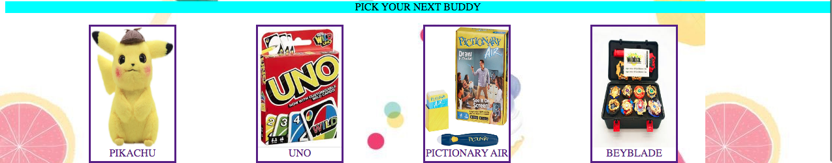

It is the first page of the website.

It displaces all the products available on the website.

Products can be selected to jump to product page.

It has a title bar, which has option for about us and contact us page.

# The **About Us page** of the Project is Shown Below:



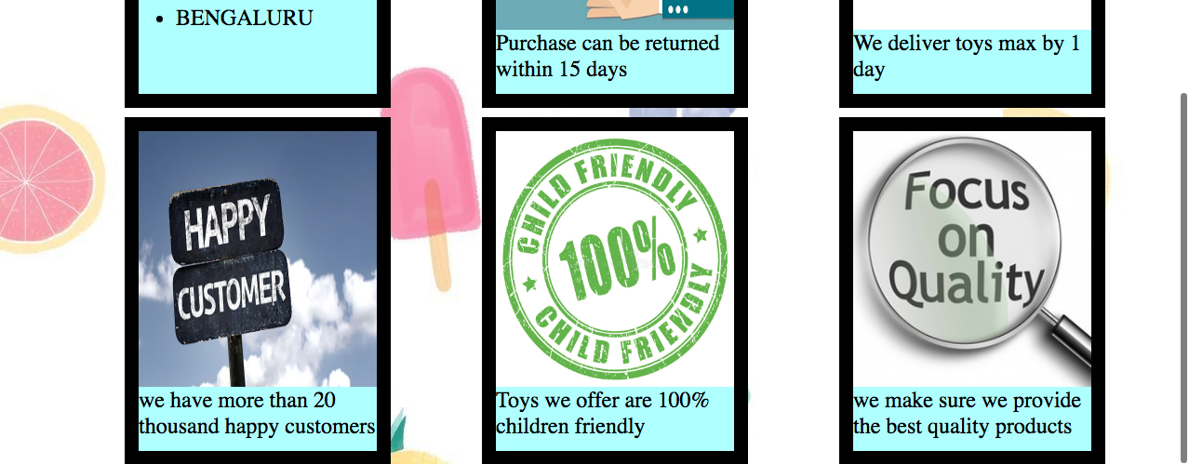

It tells us about the company like:

* Cities where they provide their service
* Return policy
* Fast delivery
* Number of current customer
* About the quality of product provided

# The **Contact Us page** of the Project is Shown Below:

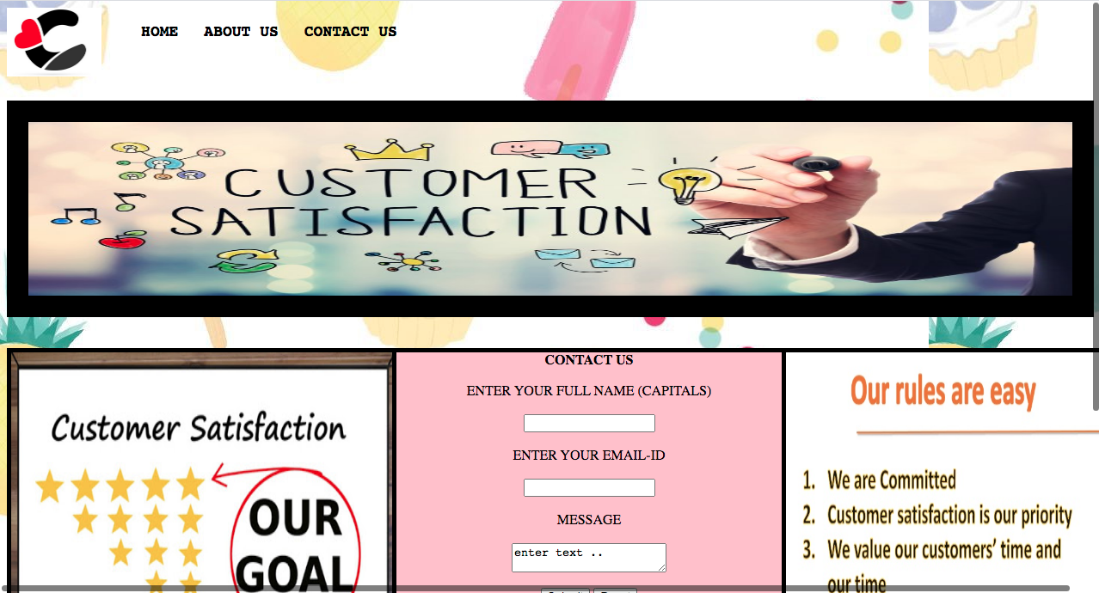

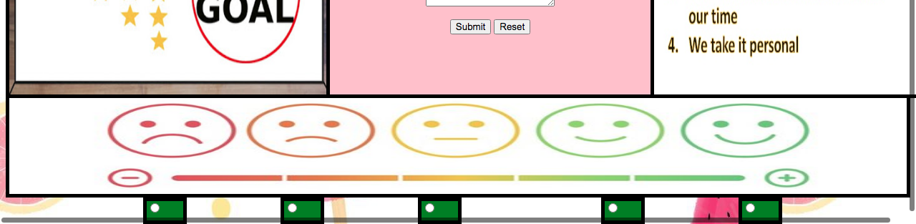

It displaces rules followed by website.

It tells about their goal of customer satisfaction.

Feedback can be given on this page.

Complaint can be done on this page.

This page act as an interface between the customer and the company .

# The **Product pages** of the Project are Shown Below:

These are webpages for individual products.

Here order can be placed for individual product.

All these pages have a common structure, which is as followed:

* Image of the product in center
* Name of the product
* Price of the product
* A section for placing order, where the following can be specified:
* Color of the product
* Number of set
* Instant delivery

#Screenshots of product web pages:

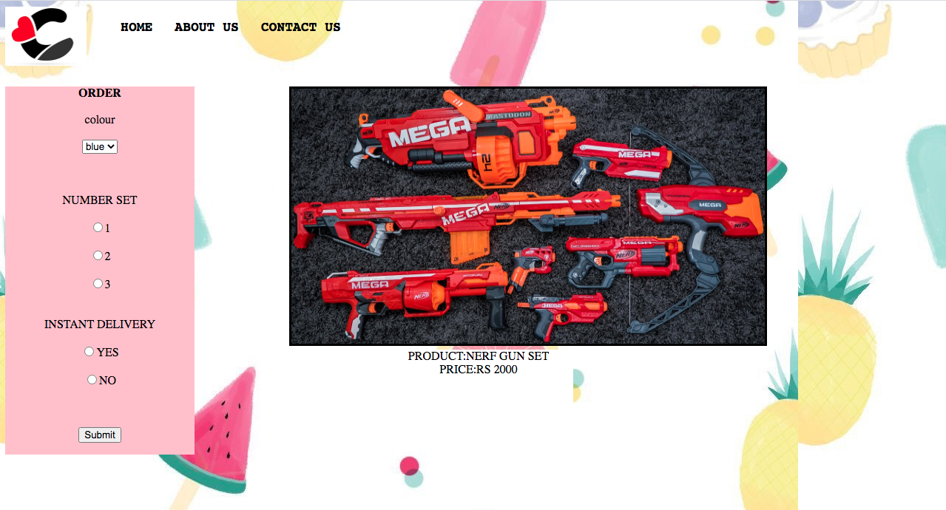

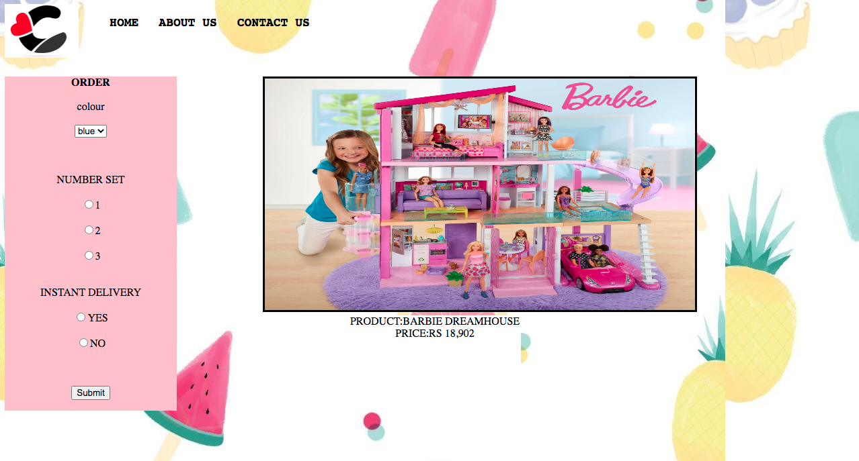

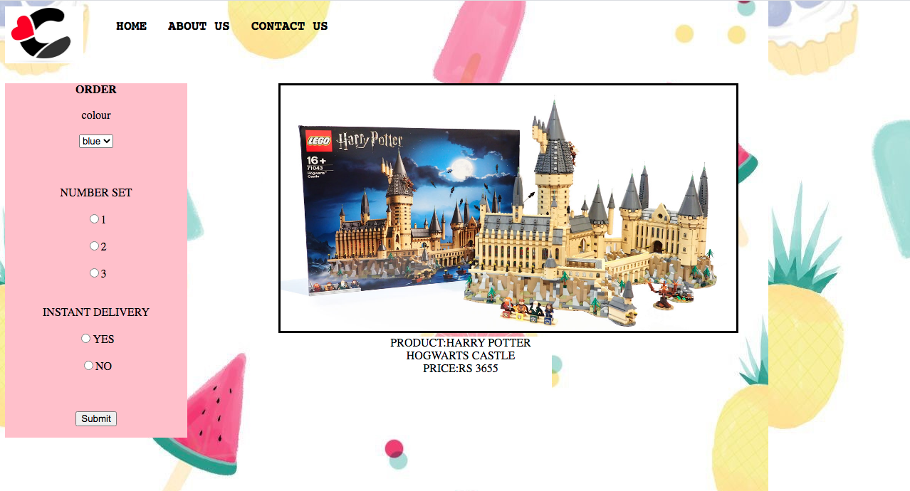

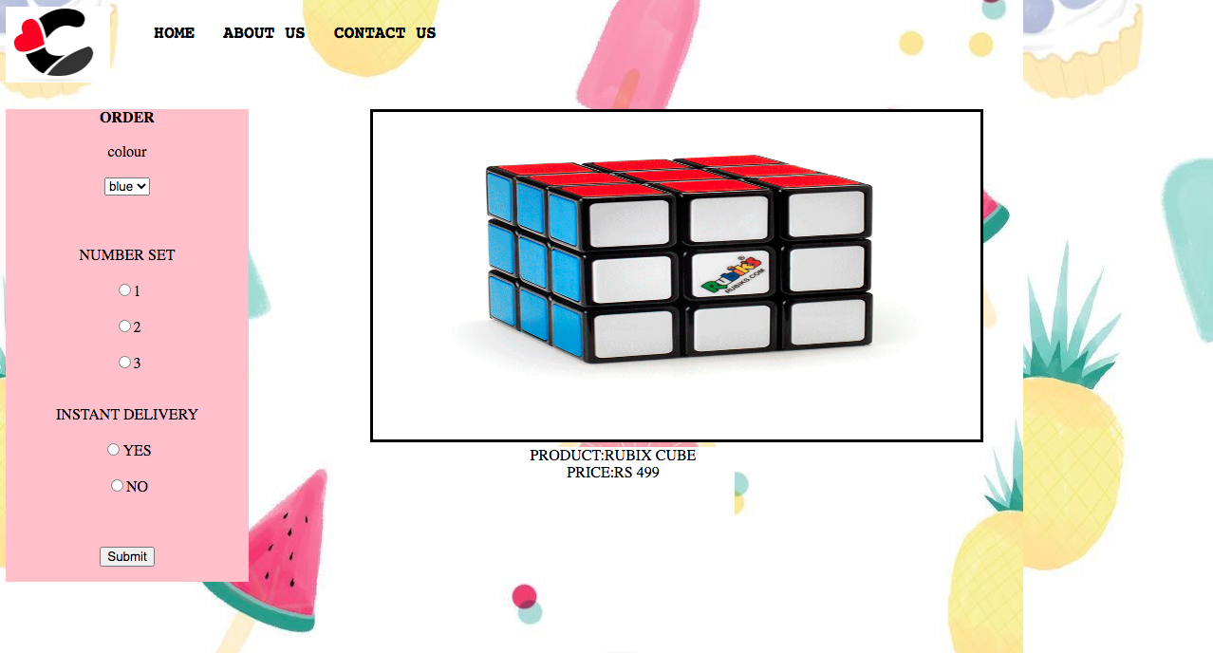

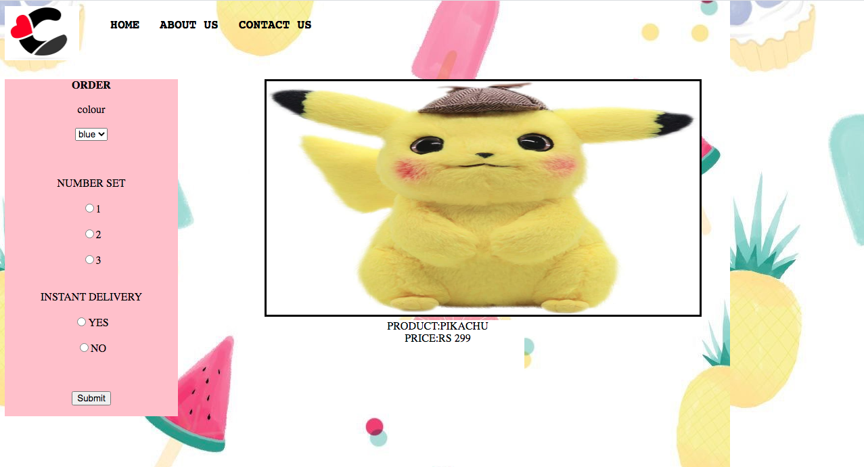

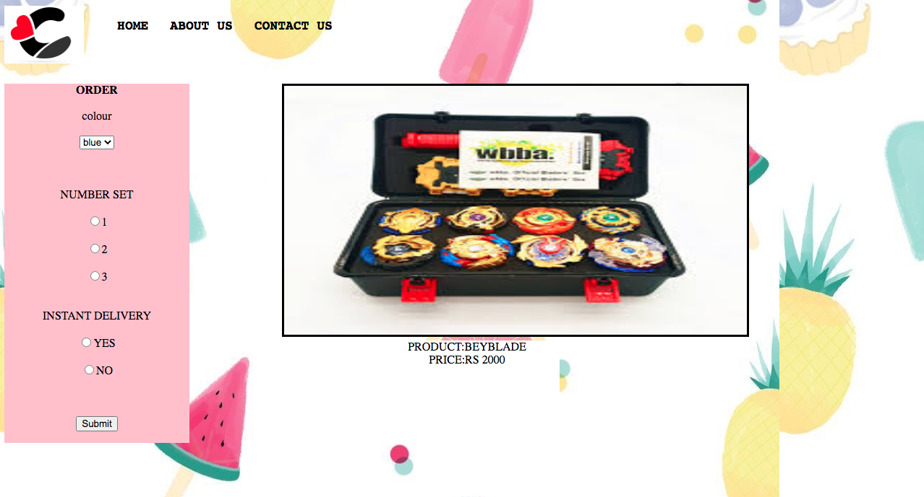

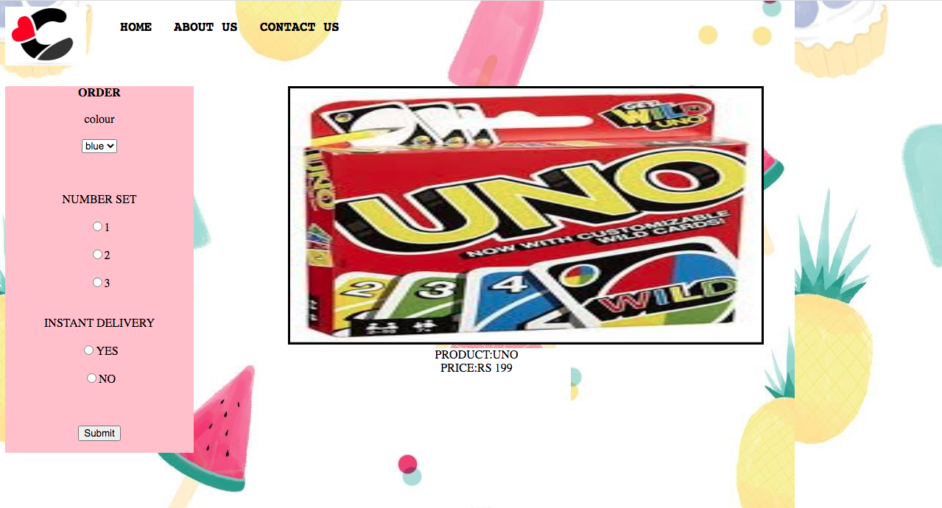

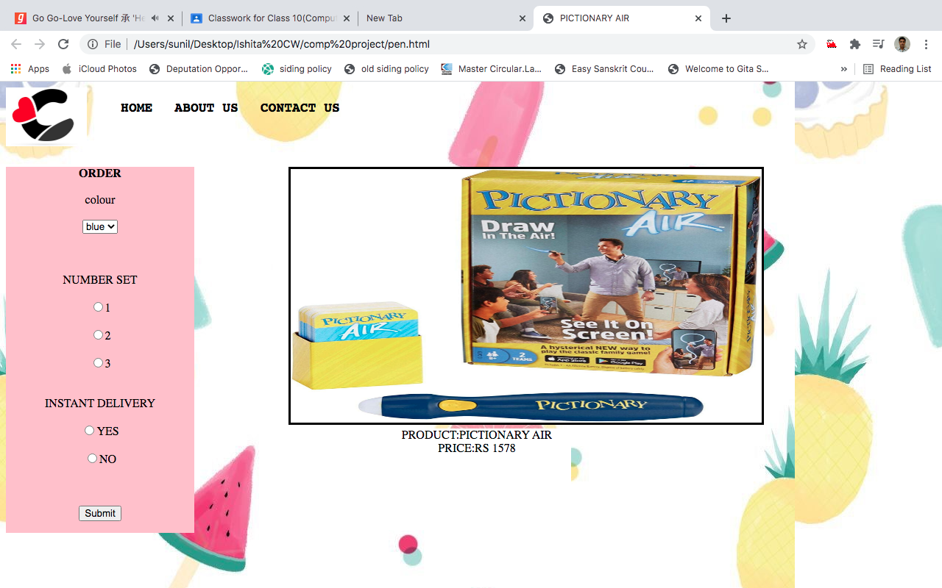

3. Source Code of the Project

**Source Code**

* **Home page**





<html>

<head>

<title>

HOME

</title>

<style>

.a{

width:8%; float:left; }

.b{

width:80%; float:left;

}

.c{

list-style-type: none; }

.d{

float:left; }

.e{

color:black;

text-decoration:none;

padding:15px 15px;

font-size:18px;

font-family:monospace;

font-weight:bold; }

a:hover{

background-color:pink; }

.f{background-image:url(wallpaper.jpg);}

.g{background-color:yellow;}

.h{background-color:white;position:absolute;height:30%;width:10%;margin-left:10%;border-style:solid;}

.i{background-color:white;position:absolute;height:30%;width:10%;margin-left:30%;border-style:solid;}

.j{background-color:white;position:absolute;height:30%;width:10%;margin-left:50%;border-style:solid;}

.k{background-color:white;position:absolute;height:30%;width:10%;margin-left:70%;border-style:solid;}

.l{background-color:white;position:absolute;height:30%;width:10%;margin-left:10%;margin-top:20%;border-style:solid;}

.m{background-color:white;position:absolute;height:30%;width:10%;margin-left:30%;margin-top:20%;border-style:solid;}

.n{background-color:white;position:absolute;height:30%;width:10%;margin-left:50%;margin-top:20%;border-style:solid;}

.o{background-color:white;position:absolute;height:30%;width:10%;margin-left:70%;margin-top:20%;border-style:solid;}

.p{background-color:aqua;}

.x{background-color:orange;height:30%;border:15px solid black;}

</style>

</head>

<body class=f>

<div class=a><img src=c.jpg width=110px></div>

<div class=b>

<ul class=c>

<li class=d><a href="home.html" class=e>HOME</a></li>

<li class=d><a href="about us .html" class=e>ABOUT US</a></li>

<li class=d><a href="CONTACT US.html" class=e>CONTACT US</a></li>

</ul>

</div><br><br><br><br><br><br>

<div class=x>

<imgsrc='10.jpg'height=100% width=100%>

</div><br><br>

<div class=g><center>ALL TIME FAVORITE</center></div><br>

<ahref=nerf.html><div class=h><img src=nerf.jpg height=90% width=100%><center>NERF</center></div></a>

<ahref=barbie.html><div class=i><img src=barbie.jpg height=90% width=100%><center>BARBIE</center></div></A>

<ahref=lego.html><div class=j><img src=lego.jpg height=90% width=100%><center>LEGO</center></div></A>

<ahref=cube.html><div class=k><img src=rubixcube.png height=90% width=100%><center>RUBIX CUBE</center></div></A><br><br><br><br><br><br><br><br><br><br><br><br><br>

<div class=p><center>PICK YOUR NEXT BUDDY</center></div><br>

<ahref=pikachu.html><div class=h><img src=pikachu.jpg height=90% width=100%><center>PIKACHU</center></div></a>

<ahref=uno.html><div class=i><img src=uno.jpg height=90% width=100%><center>UNO</center></div></a>

<ahref=pen.html><div class=j><img src=pen.jpg height=90% width=100%><center>PICTIONARY AIR</center></div></a>

<ahref=beyblade.html><div class=k><img src=beyblade.jpg height=90% width=100%><center>BEYBLADE</center></div></a>

</body>

</html>

* **About us page**





<HTML>

<HEAD>

<TITLE>

ABOUT US

</TITLE>

<style>

.a{

width:8%; float:left; }

.b{

width:80%; float:left;

}

.c{

list-style-type: none; }

.d{

float:left; }

.e{

color:black;

text-decoration:none;

padding:15px 15px;

font-size:18px;

font-family:monospace;

font-weight:bold; }

a:hover{

background-color:pink; }

.f{background-image:url(wallpaper.jpg);}

.g{background-color:orange;height:30%;border:25px solid black;}

.h{background-color:#b3ffff;height:50%;width:20%;position:absolute;MARGIN-LEFT:10%;border:15px solid black;}

.i{background-color:#b3ffff;height:50%;width:20%;position:absolute;margin-left:40%;border:15px solid black;}

.j{background-color:#b3ffff;height:50%;width:20%;position:absolute;margin-left:70%;border:15px solid black;}

.k{background-color:#b3ffff;height:50%;width:20%;position:absolute;margin-top:30%;margin-left:10%;border:15px solid black;}

.l{background-color:#b3ffff;height:50%;width:20%;position:absolute;margin-left:40%;margin-top:30%;border:15px solid black;}

.m{background-color:#b3ffff;height:50%;width:20%;position:absolute;margin-left:70%;margin-top:30%;border:15px solid black;}

</style>

</HEAD>

<BODY class=f>

<div class=a><img src=c.jpg width=110px></div>

<div class=b>

<ul class=c>

<li class=d><a href="home.html" class=e>HOME</a></li>

<li class=d><a href="about us .html" class=e>ABOUT US</a></li>

<li class=d><a href="CONTACT US.html" class=e>CONTACT US</a></li>

</ul>

</div><br><br><br><br><br><br>

<FONT SIZE= 5>

<div class=g>

<imgsrc='us3.jpg'height=100% width=100%>

</div><br><br>

<div class=h>

CITIES WHERE WE PROVIDE OUR SERVICE

<UL>

<LI>JAIPUR</LI>

<LI>DELHI</LI>

<LI>MUMBAI</LI>

<LI>CHENNAI</LI>

<LI>KOLKATA</LI>

<LI>BENGALURU</LI>

</UL>

</div>

<div class=i>

<imgsrc='3.jpg'height=80% width=100%>Purchase can be returned

within 15 days

</div>

<div class=j>

<imgsrc='1.jpg'height=80% width=100%>We deliver toys max by 1 day

</div>

<div class=k>

<imgsrc='2.jpg'height=80% width=100%>we have more than

20 thousand happy customers

</div>

<div class=l>

<imgsrc='4.jpg'height=80% width=100%>Toys we offer are 100% children friendly

</div>

<div class=m>

<imgsrc='5.jpg'height=80% width=100%>we make sure we provide the best quality products

</div>

</BODY> </HTML>

* **Contact us page**





<HTML>

<HEAD>

<title>

CONTACT US

</TITLE>

<style>

.a{

width:8%; float:left; }

.b{

width:80%; float:left;

}

.c{

list-style-type: none; }

.d{

float:left; }

.e{

color:black;

text-decoration:none;

padding:15px 15px;

font-size:18px;

font-family:monospace;

font-weight:bold; }

a:hover{

background-color:pink; }

.f{background-image:url(wallpaper.jpg);}

.g{background-color:orange;height:30%;border:25px solid black;}

.h{background-color:green;height:4%;width:4%;position:absolute;

margin-left:15%;border:5px solid black;}

.i{background-color:green;height:4%;width:4%;position:absolute;

margin-left:30%;border:5px solid black;}

.j{background-color:green;height:4%;width:4%;position:absolute;

margin-left:45%;border:5px solid black;}

.k{background-color:green;height:4%;width:4%;position:absolute;

margin-left:65%;border:5px solid black;}

.l{background-color:green;height:4%;width:4%;position:absolute;

margin-left:80%;border:5px solid black}

.y{background-color:pink;width:35%;height:55%;position:absolute;border:5px solid black}

.x{background-color:pink;width:35%;height:55%;position:absolute;margin-left:35%;border:5px solid black}

.z{background-color:pink;width:30%;height:55%;position:absolute;margin-left:70%;border:5px solid black}

.w{background-color:orange;height:30%;margin-top:25%;border:5px solid black;}

</style>

</HEAD>

<BODY class=f>

<div class=a><img src=c.jpg width=110px></div>

<div class=b>

<ul class=c>

<li class=d><a href="home.html" class=e>HOME</a></li>

<li class=d><a href="about us .html" class=e>ABOUT US</a></li>

<li class=d><a href="CONTACT US.html" class=e>CONTACT US</a></li>

</ul>

</div><br><br><br><br><br><br>

<div class=g>

<imgsrc='contact2.jpg'height=100% width=100%>

</div><br><br>

<div class=y>

<imgsrc='a.jpg'height=100% width=100%>

</div>

<div class=z>

<imgsrc='n.jpg'height=100% width=100%>

</div>

<div class=x><center>

<form>

<b>CONTACT US</b>

<br><BR>

ENTER YOUR FULL NAME (CAPITALS)<br><br>

<input type=text><br><br>

ENTER YOUR EMAIL-ID<br><br>

<input type=text><br><br>

MESSAGE<br><br>

<textarea>enter text ..</textarea><br><br>

<input type=submit><input type=reset>

</form></center></div></center>

<div class=w>

<imgsrc='contact1.jpg'height=100% width=100%>

</div>

<div class=h>

<input type=radio name=r1 value=1>

</div>

<div class=i>

<input type=radio name=r1 value=2>

</div>

<div class=j>

<input type=radio name=r1 value=3>

</div>

<div class=k>

<input type=radio name=r1 value=4>

</div>

<div class=l>

<input type=radio name=r1 value=5>

</div>

</body>

</html>

* **Product pages**
* Barbie



<HTML>

<HEAD>

<TITLE>

BARBIE

</TITLE>

<style>

.a{

width:8%; float:left; }

.b{

width:80%; float:left;

}

.c{

list-style-type: none; }

.d{

float:left; }

.e{

color:black;

text-decoration:none;

padding:15px 15px;

font-size:18px;

font-family:monospace;

font-weight:bold; }

a:hover{

background-color:pink; }

.f{background-image:url(wallpaper.jpg);}

.q{background-color:white;height:50%;width:50%;border-style:solid;position:absolute;

margin-left:30%;}

.r{background-color:pink;position:absolute;width:20%}

.s{background-color:white;height:20%;width:20%;position:absolute;margin-left:40%;margin-top:25%}

</style>

</HEAD>

<BODY class=f>

<div class=a><img src=c.jpg width=110px></div>

<div class=b>

<ul class=c>

<li class=d><a href="home.html" class=e>HOME</a></li>

<li class=d><a href="about us .html" class=e>ABOUT US</a></li>

<li class=d><a href="CONTACT US.html" class=e>CONTACT US</a></li>

</ul>

</div><br><br><br><br><br><br>

<div class=r><center><form>

<b>ORDER</b><br><br>

colour<br><br><select>

<option>blue</option>

<option>red</option>

<option>grey</option>

</select>

<br><br><br><br>

NUMBER SET <BR><br>

<input type=radio name=r1>1<BR><br>

<input type=radio name=r1>2<BR><br>

<input type=radio name=r1>3<BR><br>

<BR>

INSTANT DELIVERY<BR><br>

<input type=radio name=r2>YES<BR><br>

<input type=radio name=r2>NO<BR><br>

<BR><br>

<input type=submit>

</form>

</center>

</div>

<center><div class=q><img src=BARBIE.jpg height=100% width=100%></div></center><br><br>

<div class=s><center>PRODUCT:BARBIE DREAMHOUSE <BR>PRICE:RS 18,902</center></div>

<BR>

<body>

</html>

* Beyblade



<HTML>

<HEAD>

<TITLE>

BEYBLADE

</TITLE>

<style>

.a{

width:8%; float:left; }

.b{

width:80%; float:left;

}

.c{

list-style-type: none; }

.d{

float:left; }

.e{

color:black;

text-decoration:none;

padding:15px 15px;

font-size:18px;

font-family:monospace;

font-weight:bold; }

a:hover{

background-color:pink; }

.f{background-image:url(wallpaper.jpg);}

.q{background-color:white;height:50%;width:50%;border-style:solid;position:absolute;

margin-left:30%;}

.r{background-color:pink;position:absolute;width:20%}

.s{background-color:white;height:20%;width:20%;position:absolute;margin-left:40%;margin-top:25%}

</style>

</HEAD>

<BODY class=f>

<div class=a><img src=c.jpg width=110px></div>

<div class=b>

<ul class=c>

<li class=d><a href="home.html" class=e>HOME</a></li>

<li class=d><a href="about us .html" class=e>ABOUT US</a></li>

<li class=d><a href="CONTACT US.html" class=e>CONTACT US</a></li>

</ul>

</div><br><br><br><br><br><br>

<div class=r><center><form>

<b>ORDER</b><br><br>

colour<br><br><select>

<option>blue</option>

<option>red</option>

<option>grey</option>

</select>

<br><br><br><br>

NUMBER SET <BR><br>

<input type=radio name=r1>1<BR><br>

<input type=radio name=r1>2<BR><br>

<input type=radio name=r1>3<BR><br>

<BR>

INSTANT DELIVERY<BR><br>

<input type=radio name=r2>YES<BR><br>

<input type=radio name=r2>NO<BR><br>

<BR><br>

<input type=submit>

</form>

</center>

</div>

<center><div class=q><img src=beyblade.jpg height=100% width=100%></div></center><br><br>

<div class=s><center>PRODUCT:BEYBLADE<BR>PRICE:RS 2000</center></div>

<BR>

<body>

</html>

* Rubix Cube



<HTML>

<HEAD>

<TITLE>

RUBIX CUBE

</TITLE>

<style>

.a{

width:8%; float:left; }

.b{

width:80%; float:left;

}

.c{

list-style-type: none; }

.d{

float:left; }

.e{

color:black;

text-decoration:none;

padding:15px 15px;

font-size:18px;

font-family:monospace;

font-weight:bold; }

a:hover{

background-color:pink; }

.f{background-image:url(wallpaper.jpg);}

.q{background-color:white;height:50%;width:50%;border-style:solid;position:absolute;

margin-left:30%;}

.r{background-color:pink;position:absolute;width:20%}

.s{background-color:white;height:20%;width:20%;position:absolute;margin-left:40%;margin-top:25%}

</style>

</HEAD>

<BODY class=f>

<div class=a><img src=c.jpg width=110px></div>

<div class=b>

<ul class=c>

<li class=d><a href="home.html" class=e>HOME</a></li>

<li class=d><a href="about us .html" class=e>ABOUT US</a></li>

<li class=d><a href="CONTACT US.html" class=e>CONTACT US</a></li>

</ul>

</div><br><br><br><br><br><br>

<div class=r><center><form>

<b>ORDER</b><br><br>

colour<br><br><select>

<option>blue</option>

<option>red</option>

<option>grey</option>

</select>

<br><br><br><br>

NUMBER SET <BR><br>

<input type=radio name=r1>1<BR><br>

<input type=radio name=r1>2<BR><br>

<input type=radio name=r1>3<BR><br>

<BR>

INSTANT DELIVERY<BR><br>

<input type=radio name=r2>YES<BR><br>

<input type=radio name=r2>NO<BR><br>

<BR><br>

<input type=submit>

</form>

</center>

</div>

<center><div class=q><img src=rubixcube.png height=100% width=100%></div></center><br><br>

<div class=s><center>PRODUCT:RUBIX CUBE<BR>PRICE:RS 499</center></div>

<BR>

<body>

</html>

* Lego



<HTML>

<HEAD>

<TITLE>

LEGO

</TITLE>

<style>

.a{

width:8%; float:left; }

.b{

width:80%; float:left;

}

.c{

list-style-type: none; }

.d{

float:left; }

.e{

color:black;

text-decoration:none;

padding:15px 15px;

font-size:18px;

font-family:monospace;

font-weight:bold; }

a:hover{

background-color:pink; }

.f{background-image:url(wallpaper.jpg);}

.q{background-color:white;height:50%;width:50%;border-style:solid;position:absolute;

margin-left:30%;}

.r{background-color:pink;position:absolute;width:20%}

.s{background-color:white;height:20%;width:20%;position:absolute;margin-left:40%;margin-top:25%}

</style>

</HEAD>

<BODY class=f>

<div class=a><img src=c.jpg width=110px></div>

<div class=b>

<ul class=c>

<li class=d><a href="home.html" class=e>HOME</a></li>

<li class=d><a href="about us .html" class=e>ABOUT US</a></li>

<li class=d><a href="CONTACT US.html" class=e>CONTACT US</a></li>

</ul>

</div><br><br><br><br><br><br>

<div class=r><center><form>

<b>ORDER</b><br><br>

colour<br><br><select>

<option>blue</option>

<option>red</option>

<option>grey</option>

</select>

<br><br><br><br>

NUMBER SET <BR><br>

<input type=radio name=r1>1<BR><br>

<input type=radio name=r1>2<BR><br>

<input type=radio name=r1>3<BR><br>

<BR>

INSTANT DELIVERY<BR><br>

<input type=radio name=r2>YES<BR><br>

<input type=radio name=r2>NO<BR><br>

<BR><br>

<input type=submit>

</form>

</center>

</div>

<center><div class=q><img src=LEGO.jpg height=100% width=100%></div></center><br><br>

<div class=s><center>PRODUCT:HARRY POTTER HOGWARTS CASTLE<BR>PRICE:RS 3655</center></div>

<BR>

<body>

</html>

* Nerf



<HTML>

<HEAD>

<TITLE>

NEFF

</TITLE>

<style>

.a{

width:8%; float:left; }

.b{

width:80%; float:left;

}

.c{

list-style-type: none; }

.d{

float:left; }

.e{

color:black;

text-decoration:none;

padding:15px 15px;

font-size:18px;

font-family:monospace;

font-weight:bold; }

a:hover{

background-color:pink; }

.f{background-image:url(wallpaper.jpg);}

.q{background-color:white;height:50%;width:50%;border-style:solid;position:absolute;

margin-left:30%;}

.r{background-color:pink;position:absolute;width:20%}

.s{background-color:white;height:20%;width:20%;position:absolute;margin-left:40%;margin-top:25%}

</style>

</HEAD>

<BODY class=f>

<div class=a><img src=c.jpg width=110px></div>

<div class=b>

<ul class=c>

<li class=d><a href="home.html" class=e>HOME</a></li>

<li class=d><a href="about us .html" class=e>ABOUT US</a></li>

<li class=d><a href="CONTACT US.html" class=e>CONTACT US</a></li>

</ul>

</div><br><br><br><br><br><br>

<div class=r><center><form>

<b>ORDER</b><br><br>

colour<br><br><select>

<option>blue</option>

<option>red</option>

<option>grey</option>

</select>

<br><br><br><br>

NUMBER SET <BR><br>

<input type=radio name=r1>1<BR><br>

<input type=radio name=r1>2<BR><br>

<input type=radio name=r1>3<BR><br>

<BR>

INSTANT DELIVERY<BR><br>

<input type=radio name=r2>YES<BR><br>

<input type=radio name=r2>NO<BR><br>

<BR><br>

<input type=submit>

</form>

</center>

</div>

<center><div class=q><img src=nerf.jpg height=100% width=100%></div></center><br><br>

<div class=s><center>PRODUCT:NERF GUN SET<BR>PRICE:RS 2000</center></div>

<BR>

<body>

</html>

* Pen



<HTML>

<HEAD>

<TITLE>

PICTIONARY AIR

</TITLE>

<style>

.a{

width:8%; float:left; }

.b{

width:80%; float:left;

}

.c{

list-style-type: none; }

.d{

float:left; }

.e{

color:black;

text-decoration:none;

padding:15px 15px;

font-size:18px;

font-family:monospace;

font-weight:bold; }

a:hover{

background-color:pink; }

.f{background-image:url(wallpaper.jpg);}

.q{background-color:white;height:50%;width:50%;border-style:solid;position:absolute;

margin-left:30%;}

.r{background-color:pink;position:absolute;width:20%}

.s{background-color:white;height:20%;width:20%;position:absolute;margin-left:40%;margin-top:25%}

</style>

</HEAD>

<BODY class=f>

<div class=a><img src=c.jpg width=110px></div>

<div class=b>

<ul class=c>

<li class=d><a href="home.html" class=e>HOME</a></li>

<li class=d><a href="about us .html" class=e>ABOUT US</a></li>

<li class=d><a href="CONTACT US.html" class=e>CONTACT US</a></li>

</ul>

</div><br><br><br><br><br><br>

<div class=r><center><form>

<b>ORDER</b><br><br>

colour<br><br><select>

<option>blue</option>

<option>red</option>

<option>grey</option>

</select>

<br><br><br><br>

NUMBER SET <BR><br>

<input type=radio name=r1>1<BR><br>

<input type=radio name=r1>2<BR><br>

<input type=radio name=r1>3<BR><br>

<BR>

INSTANT DELIVERY<BR><br>

<input type=radio name=r2>YES<BR><br>

<input type=radio name=r2>NO<BR><br>

<BR><br>

<input type=submit>

</form>

</center>

</div>

<center><div class=q><img src=pen.jpg height=100% width=100%></div></center><br><br>

<div class=s><center>PRODUCT:PICTIONARY AIR<BR>PRICE:RS 1578</center></div>

<BR>

<body>

</html>

* Pikachu



<HTML>

<HEAD>

<TITLE>

PIKACHU

</TITLE>

<style>

.a{

width:8%; float:left; }

.b{

width:80%; float:left;

}

.c{

list-style-type: none; }

.d{

float:left; }

.e{

color:black;

text-decoration:none;

padding:15px 15px;

font-size:18px;

font-family:monospace;

font-weight:bold; }

a:hover{

background-color:pink; }

.f{background-image:url(wallpaper.jpg);}

.q{background-color:white;height:50%;width:50%;border-style:solid;position:absolute;

margin-left:30%;}

.r{background-color:pink;position:absolute;width:20%}

.s{background-color:white;height:20%;width:20%;position:absolute;margin-left:40%;margin-top:25%}

</style>

</HEAD>

<BODY class=f>

<div class=a><img src=c.jpg width=110px></div>

<div class=b>

<ul class=c>

<li class=d><a href="home.html" class=e>HOME</a></li>

<li class=d><a href="about us .html" class=e>ABOUT US</a></li>

<li class=d><a href="CONTACT US.html" class=e>CONTACT US</a></li>

</ul>

</div><br><br><br><br><br><br>

<div class=r><center><form>

<b>ORDER</b><br><br>

colour<br><br><select>

<option>blue</option>

<option>red</option>

<option>grey</option>

</select>

<br><br><br><br>

NUMBER SET <BR><br>

<input type=radio name=r1>1<BR><br>

<input type=radio name=r1>2<BR><br>

<input type=radio name=r1>3<BR><br>

<BR>

INSTANT DELIVERY<BR><br>

<input type=radio name=r2>YES<BR><br>

<input type=radio name=r2>NO<BR><br>

<BR><br>

<input type=submit>

</form>

</center>

</div>

<center><div class=q><img src=pikachu.jpg height=100% width=100%></div></center><br><br>

<div class=s><center>PRODUCT:PIKACHU<BR>PRICE:RS 299</center></div>

<BR>

<body>

</html>

* Uno



<HTML>

<HEAD>

<TITLE>

UNO

</TITLE>

<style>

.a{

width:8%; float:left; }

.b{

width:80%; float:left;

}

.c{

list-style-type: none; }

.d{

float:left; }

.e{

color:black;

text-decoration:none;

padding:15px 15px;

font-size:18px;

font-family:monospace;

font-weight:bold; }

a:hover{

background-color:pink; }

.f{background-image:url(wallpaper.jpg);}

.q{background-color:white;height:50%;width:50%;border-style:solid;position:absolute;

margin-left:30%;}

.r{background-color:pink;position:absolute;width:20%}

.s{background-color:white;height:20%;width:20%;position:absolute;margin-left:40%;margin-top:25%}

</style>

</HEAD>

<BODY class=f>

<div class=a><img src=c.jpg width=110px></div>

<div class=b>

<ul class=c>

<li class=d><a href="home.html" class=e>HOME</a></li>

<li class=d><a href="about us .html" class=e>ABOUT US</a></li>

<li class=d><a href="CONTACT US.html" class=e>CONTACT US</a></li>

</ul>

</div><br><br><br><br><br><br>

<div class=r><center><form>

<b>ORDER</b><br><br>

colour<br><br><select>

<option>blue</option>

<option>red</option>

<option>grey</option>

</select>

<br><br><br><br>

NUMBER SET <BR><br>

<input type=radio name=r1>1<BR><br>

<input type=radio name=r1>2<BR><br>

<input type=radio name=r1>3<BR><br>

<BR>

INSTANT DELIVERY<BR><br>

<input type=radio name=r2>YES<BR><br>

<input type=radio name=r2>NO<BR><br>

<BR><br>

<input type=submit>

</form>

</center>

</div>

<center><div class=q><img src=uno.jpg height=100% width=100%></div></center><br><br>

<div class=s><center>PRODUCT:UNO<BR>PRICE:RS 199</center></div>

<BR>

<body>

</html>